Confidential Patient Information

Dr………………………………………… Date:……………………..

Name: Mr. / Mrs. / Miss Home Phone:
Address: Work Phone:
Suburb: P/Code: Mobile Phone:
DOB: ___/___/___ AGE: ___ M/F ___ Email: _______________________________________________________________
Name of Spouse (or parent, if minor) and DOB: Please Indicate €
Name/s of Children and DOB:
Referred By | Concession
€ Friend/Relation | € Pension Card
_______________ | € Student Card
€ Yellow Pages | € Health C Card
€ Drive/Walk By | € Child U 18
€ Other | € Workcover
_______________ | € DVA

Occupation: _____________________Employed by:
Who Is Responsible For Account?
Do You Have Health Insurance? Y / N What Company?
Is Your Present Condition Covered By Workers Compensation? Y / N
Emergency Contact: Name___________________________Phone:__________________

Signature: ________________________________

Patient Case History

Dear Patient: Please complete this questionnaire. Your answers will help us to determine if chiropractic can help you. If we do not sincerely believe your condition will respond satisfactorily, we will not accept your case. THANK YOU.

THIS IS A CONFIDENTIAL HEALTH REPORT

CHECK OFF ANY OF THE FOLLOWING CONDITIONS YOU HAVE HAD OR HAVE
PLEASE TICK
GENERAL | GASTRO-INTESTINAL | RESPIRATORY
- Allergy | - Belching or gas | - Chest pain
- Dizziness | - Colon trouble | - Chronic cough
- Fatigue | - Constipation | - Difficult breathing
- Headache | - Diarrhea | - Asthma
- Loss of sleep | - Difficult digestion
- Nervousness/depression | - Gall bladder trouble | - SKIN
- Numbness | - Hemorrhoids | - Bruise easily
 | - Liver trouble | - Dryness
MUSCLE AND JOINT | - Nausea | - Itching
- Low back pain | - Poor appetite | - Psoriasis
- Neck pain or stiffness | - Hiatus Hernia
- Pain between shoulders |  | GENITO-URINARY
- Swollen joints | EYES, EARS, NOSE & THROAT | - Bed wetting
- Arm pain | - Earaches | - Frequent urination
- Leg pain | - Enlarged glands | - Painful urination
- Knee pain | - Eye pain | - Kidney infection
- Foot pain | - Sinus problems | - Prostate trouble
- Ankle pain | - Blurred vision | - Testicular pain
- Hand pain | - Hearing loss
WOMEN ONLY | CARDIO-VASCULAR
- Excessive menstrual flow | - Blood pressure
- Irregular cycles | - Poor circulation
- Painful menstruation | - Rapid heart beat
- Vaginal discharge | - Slow heart beat
- Ovarian cysts | - Swelling of ankles
- Fibroids
- Thrush

Have you been in an auto accident? € Past year € Past 5 years € Over 5 years € Never
Describe
Have you had chiropractic care before? Y / N When ?
Where? By Dr.
What is your major complaint? Please Illustrate affected areas
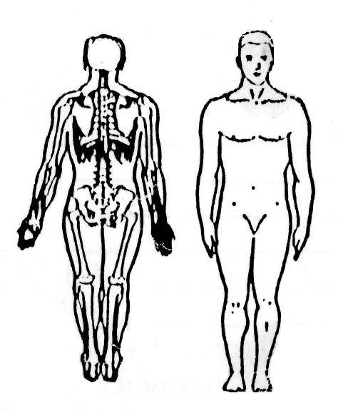

How long have you had this condition?
Have you had this or similar conditions in the past?
What activities aggravate your condition?
Is this condition getting progressively worse? € Yes € No € Constant € Comes and goes
Is this condition interfering with your: € Work € Sleep € Daily routine € Other
Other complaints

How long has it been since you felt good?
List surgical operations and years:

Are you pregnant? ________________________________ Due Date:
Exercise programs & sports
Your Medical Dr. is
FAMILY HEALTH INFORMATION (Many health problems are the result of hereditary spinal weaknesses, thus information about your family members will give us a better picture of your total health picture.)
Examination | Date:
 | L | R
Posture
Bilateral Scales
Ears
Shoulders
Hips
Body Lean
Head Lean
Ant. Head
Neck Motion
Flexion 65
Extension 65
Lat. Flex. 45
Rotation 90
Lumbar Motion
Flexion 90
Ext / Kemps 35
Muscle Strength
Deltoid
Grasp
Pinch
Psoas
SLR
Leg Length
Leg Lift Prone
Static Palp
Heal Toe Test
Visual A. S.
Other
Follow up WL

NAME | RELATION | PAST & PRESENT HEALTH PROBLEMS

DATE OF LAST | Less than 6 months | 6-18 months | Over 18 months | Never
Spinal examination
Physical examination
Blood test
Chest x-ray
Spinal x-ray
Dental x-ray
Urine test

DO YOU:
Now take vitamins or minerals?
Describe

Now take drugs of any kind?
Describe

PLEASE DO NOT WRITE BELOW THIS SPACE

